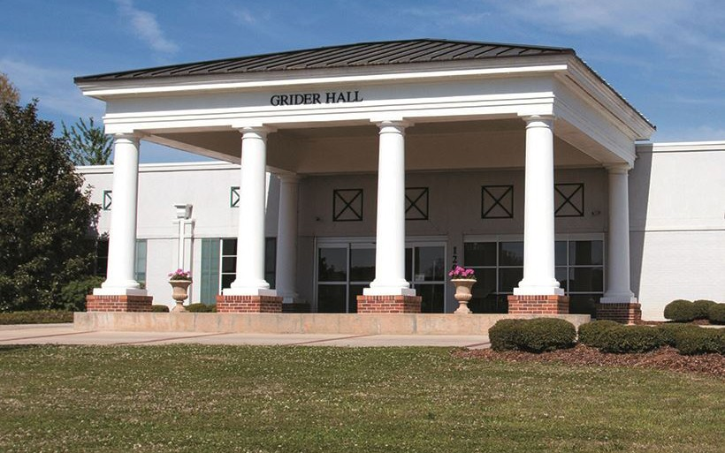Image of Alabama Institute for Deaf and Blind logo; blue housetop with red A I D B letters with blue base deaf.blind.limitless

E. H. GENTRY FACILITY

**E. H. Gentry Facility (EHG)** is a full-service vocational and educational rehabilitation program which serves adults who are deaf, blind, deafblind, and those with other or multiple accommodation needs. Our primary goal is to help students discover their limitless potential by achieving economic and personal independence through employment training, college preparation classes, and independent living skills. EHG offers a variety of support services for all students, including individuals diagnosed with Autism Spectrum Disorder (ASD) and their families through distance learning or all conveniently located on our beautiful campus in Talladega, Alabama.

|  |  |  |
| --- | --- | --- |
| **Services & Offerings** | | |
| **Evaluation Services**   * Academic Proficiency * Academic Remediation * Academics * Academic Tests * Alabama Career Essentials * Aptitude Testing * Assessments/Situational Assessments * Communication/Vocabulary Enrichment * Interests/Career Explorations * Money Management * Specialized Test Preparation   **College Prep-Dual Enrollment**   * College Preparation * Dual Enrollment * Transition Services * Tutoring/Remediation   **Specialized Classes**   * Adjustment to Blindness * ASL/American Sign Language * Braille (4 types) * Distance Learning Options * Driver’s Education * Finding Wheels (Transportation) * Orientation & Mobility * Safe Without Sight (Self-Defense)   **Assistive Technology**   * AIRA Services * Assistive Technology for the Deaf, Blind, and DeafBlind * iCanConnect – National Deaf-Blind Equipment Distribution Program (NDBEDP) | **Employment Training & Work Experience**   * Accommodations’ Requests * Career Exploration * Conflict Resolution * Critical Thinking and Problem-Solving Skills * Hospitality Training * HVAC Pre-Fabrication Training * Interviewing Skills Preparation * Job Search/Application Assistance and Networking * Landscaping/Agricultural/Horticultural Training * Pre-construction Training * Residential Advisor Training * Resume Development * Workplace Communication * Workplace Ethics * Partnerships with Alabama Industrial Development Training (AIDT) and * Associated Builders & Contractors of Alabama   **Certification Areas**   * Alabama Certified Workers Certification * Automotive Service Excellence (ASE) * Certified Nursing Assistant (CNA) * Commercial Driver’s License (CDL) * CPR/First Aid * Forklift Certification * Manufacturing Skills Standards Council Certifications (MSSC) * Microsoft Office Specialist (MOS) * National Career Readiness Certification - WorkKeys * Northstar Digital Literacy Certification * Phlebotomy Technician * Salesforce Certification * ServSafe Certification * Partnerships with Alabama Community College System | **Business Enterprise Program (BEP)**   * Experiential Learning * Federal/State Guidelines for BEP * ServSafe Certification * Small Business Operations * QuickBooks Training * Snack Bar/Cafe Operations * Vending Operations   **DeafBlind Services**   * Alternative Communication * Computer Instruction & Adaptive Technology * Orientation & Mobility * Support Service Provider (SSP) Training   **Autism Spectrum Disorder (ASD) Services**   * Applied Behavior Analysis (ABA) Therapy * Behavior Consultation * Collaboration with Education and Rehabilitation Teams * Parent Support Groups and Workshops   **Independent Living Skills**   * Food Science and Nutrition * Life Skills * Money Management/Budgeting * Personal/Home Management   **Extended Day Program**   * Exercise Room * Independent Living Apartments * Laundry Services * Local Transportation Services * Recreational Areas and Activities * Semi-Independent Apartments * Student Advisory Council |
| **Contact Information** | | |

|  |  |  |  |
| --- | --- | --- | --- |
| **Jessica Edmiston**  Executive Director  O: 256-761-3402  C: 256-493-3360  edmiston.jessica@aidb.org | **Josh Sharpton**  Director of Services for the Deaf & DeafBlind  VP: 256-358-7555  sharpton.josh@aidb.org | **Dr. M. Yevette Pearce**  Director of Student & General Services, and Adult Education  O: 256-761-3695  VP: 256-474-0776  pearce.yevetter@aidb.org | **Melissa Norred**  ADRS Liaison Counselor  256-761-3415  norred.melissa@rehab.alabama.gov  P.O. Box 698 | 1105 Fort Lashley Ave.  Talladega, AL 35161  1-888-774-2335  www.AIDB.org/EHG  Hours of Operation:  Monday – Friday | 8 AM – 4 PM |
| **Donte’ Little**  Assistant Director  to the Executive Director  O: 256-761-3402  C: 334-329-8212  little.donte@aidb.org | **Rod Skene**  Director of Services for the Blind, Assistive Technology, and  Business Enterprise Program  O: 256-761-3406  skene.rod@aidb.org | **Connie Johnson**  Director of Extended Day, Recreation, and Laundry  O: 256-761-3674  johnson.connie@aidb.org |