DAY-LONG LEARNING  Students stay in our dorm with highly qualified staff and around-the-clock supervision.  Life in the dorm is an extension of the classroom, empowering students to learn and practice independence, social, and self-advocacy skills.  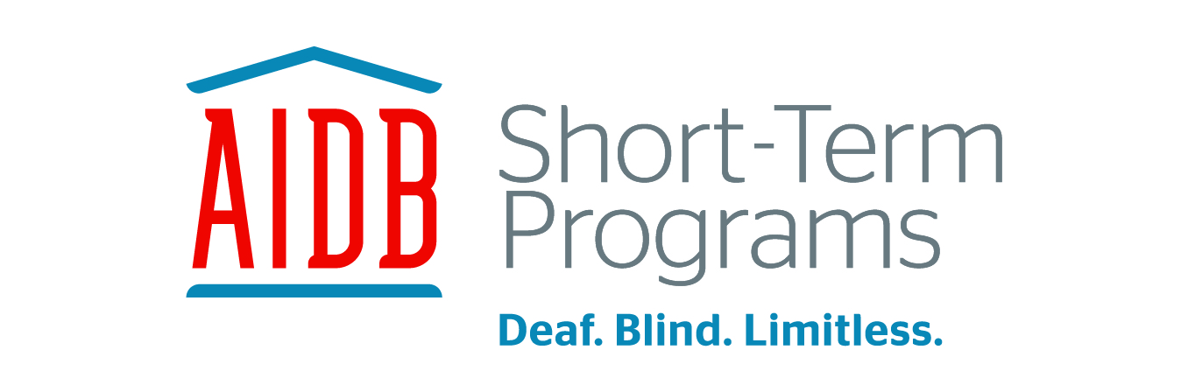  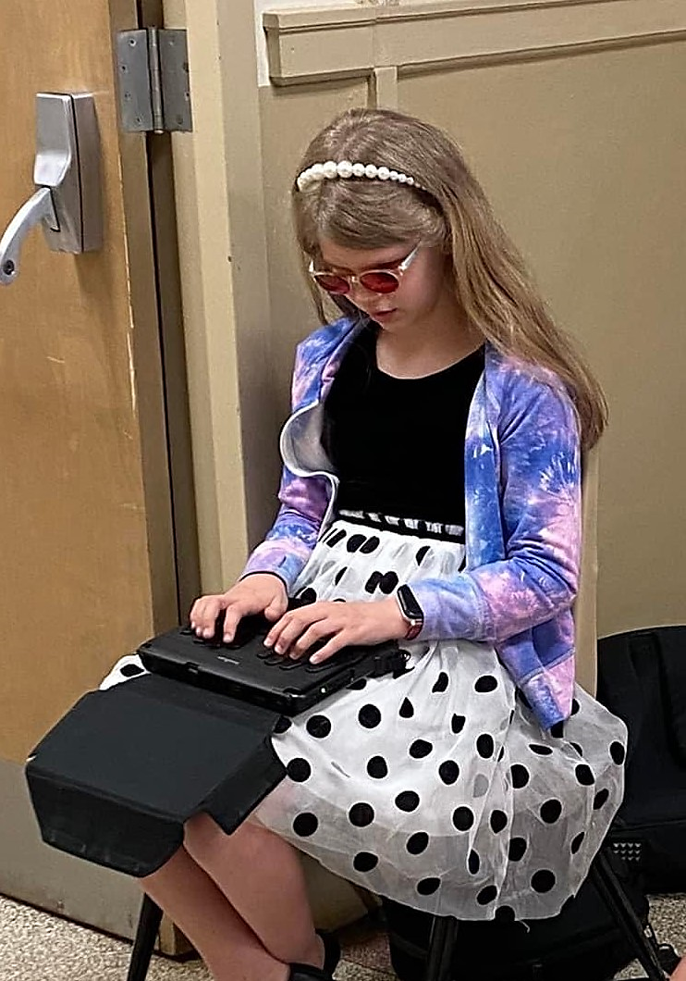 |  | Street Address  City, ST ZIP Code | AIDB Short-Term Programs  Jessica Chapa, Director  4104 US Highway 31 South  Decatur, Alabama 35603  Office # 256-761-3850  shorttermprograms@aidb.org |  | Short-Term Programs  - Mission Statement: To equip students who are blind and/or visually impaired with the necessary skills needed to reach their limitless potential in education, independence, and career through the in-depth learning of the Expanded Core Curriculum.  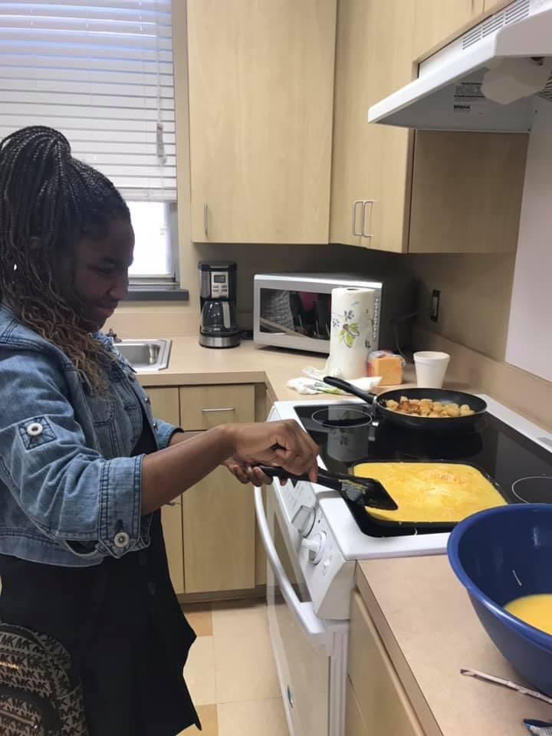

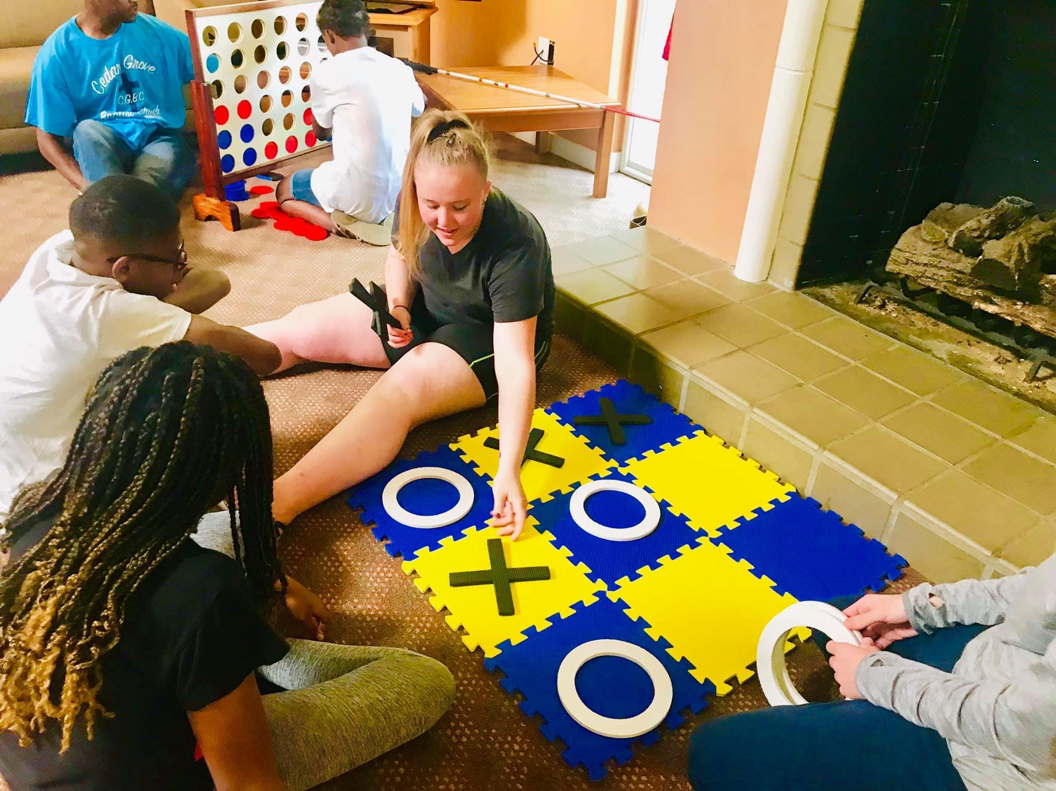  WHO ARE WE?  Short-Term Programs at Alabama Institute for Deaf and Blind (AIDB) offers three to seven day courses that focus on specific needs of Alabama’s students who have visual impairments.  WHO CAN ATTEND?  Students who have visual impairments and attend their local school during the academic year.  Students must not exhibit behaviors that disrupt their own learning or that of others in the program.  Courses are available for students in 6th-12th grades. | Examples of Courses within Short-Term Programs  The Great AIDB Bake Off: 9th-12th grades  This course gives students specific instructions in cooking techniques and adaptations in order to learn to prepare meals in the kitchen.  Game of Life:6th-12th grades  This weekend course gives both parents and students the opportunity to gain resources and learning opportunities together.  STP Formal Dance: 9th-12th grades  This course provides students with the opportunity to gain independent living skills, as well as social and self-determination skills.  Access to Curriculum: 6th-12th grades  This is a highly intensive course that focuses on compensatory skills needed by learners to access the general education curriculum.  Everything Braille/Nemeth Code:  6th-8th grades  These courses are designed for students who need intensive instruction in either Braille or Nemeth Code.  For all course listings, descriptions, and schedule please visit our website at:  www.aidb.org/STPCourseListing  *All courses are free for families and schools.* | LIFE-ENRICHING  For many students who attend public school, private school, or homeschool, a Short-Term Programs course may be their first opportunity to connect with peers who have visual impairments. Students will make lifelong friends and improve their social skills through participation.  Experiencing fully-accessible instruction and enjoyable activities with peers often leads to surprising leaps in self-concept and self-confidence.  EXPANDED CORE CURRICULUM  Short-Term Programs provides instruction in nearly all areas of the Expanded Core Curriculum, including Independent Living Skills, Technology, Orientation and Mobility, Social Skills, Recreation and Leisure, and Access to the Curriculum through tools from Nemeth Code to telescopes.

